Python实现推箱子游戏
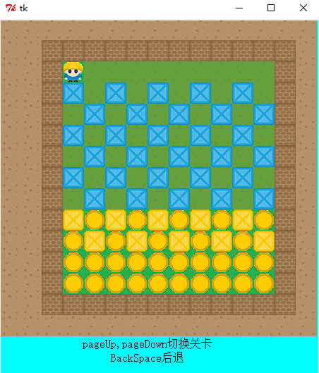
#encoding:utf-8
import tkMessageBox
from Tkinter import Tk, Canvas, Frame
from PIL import ImageTk, Image

img = []

def load_picture():
global img
for i in range(0, 10):
file = "F:/source/" + str(i) + ".bmp"
im = Image.open(file)
im = ImageTk.PhotoImage(im)
img.append(im)

class Grid:
def __init__(self, master = None, window_width = 450, window_height = 500, width = 30):
self.master = master
self.width = width
self.map = []
self.load_map(1)
self.canvas = Canvas(master, width = window_width, height = window_height, bg = 'cyan')

self.canvas.pack()
self.display_map()

def load_map(self, i):
file = "F:/source/" + str(i) + ".txt"
f = open(file, "r")
lines = f.readlines()
for k in range(0, len(self.map)):
self.map.pop()
for k in range(0, len(lines)):
mp = []
line = lines[k]
for j in range(0, len(lines)):
p = int(line[j])
mp.append(p)
if p == 6:
self.x = k
self.y = j
self.map.append(mp)

def display_map(self):
self.canvas.delete('all') #清空画布canvas
m = len(self.map)
n = len(self.map[0])
for i in range(0, m):
for j in range(0, n):
self.create_image(i, j)

self.display_text()

def display_text(self):
self.canvas.create_text(210, 460, text = "pageUp,pageDown切换关卡", font = 'BOLD', fill = 'black')
self.canvas.create_text(210, 480, text = "BackSpace后退", font = 'BOLD', fill = 'black')

def create_image(self, i, j):
global img
x = (2 * i + 1) * self.width / 2
y = (2 * j + 1) * self.width / 2
pic = self.map[i][j]
self.canvas.create_image(y, x, image = img[pic])

class Game(Frame):
def __init__(self, master = None):
Frame.__init__(self, master)
self.grid = Grid(self.master)
self.direction = 'Down'
self.map = []
self.get_map() # 获取地图，用于标志地图中最初箱子放在目标位置
self.stack = [1]
self.level = 1
self.dir_x = [-1, 1, 0, 0]
self.dir_y = [0, 0, -1, 1]
self.dir = {'Up':0, 'Down':1, 'Left':2, 'Right':3}
self.bind_all("<KeyPress>", self.KeyPress_event)

def get_map(self):
for k in range(0, len(self.map)):
self.map.pop()
for i in self.grid.map:
mp = []
for j in i:
mp.append(j)
self.map.append(mp)

def KeyPress_event(self, event):
key = event.keysym
if self.dir.has_key(key):
self.direction = key
self.move()
elif key == 'Prior':
self.prior_level()
elif key == 'Next':
self.next_level()
elif key == 'BackSpace':
if len(self.stack) == 1:
return
cur_dir = self.stack.pop() # 当前坐标的方向
# 当前坐标
mx = self.stack.pop()
my = self.stack.pop()

cur_picture = self.stack.pop() # 当前坐标cur_dir方向的图片
next_picture = self.stack.pop() # 前一个坐标以前图片
pre_dir = self.stack[len(self.stack) - 1]
dx = self.dir_x[cur_dir]
dy = self.dir_y[cur_dir]
self.grid.map[mx][my] = cur_picture
self.grid.map[mx + dx][my + dy] = next_picture
self.grid.map[mx - dx][my - dy] = pre_dir + 5
self.grid.x = mx - dx
self.grid.y = my - dy
self.grid.display_map()

def move(self):
index = self.dir[self.direction]
x = self.grid.x # 原来的位置
y = self.grid.y
dx = self.dir_x[index] # 位移
dy = self.dir_y[index]
mp = self.grid.map
self.grid.x += dx
self.grid.y += dy
manX = self.grid.x
manY = self.grid.y

origin_picture = mp[manX][manY]
next_picture = mp[manX + dx][manY + dy]

# dir方向是箱子，箱子dir方向是墙或箱子
if (mp[manX][manY] == 4 or mp[manX][manY] == 3) and (mp[manX + dx][manY + dy] == 2 or mp[manX + dx][manY + dy] == 3 or mp[manX + dx][manY + dy] == 4):
self.grid.x -= dx
self.grid.y -= dy
return

# dir方向是墙
if mp[manX][manY] == 2:
self.grid.x -= dx
self.grid.y -= dy
return

# dir方向是草地或者目的地
if mp[manX][manY] == 1 or mp[manX][manY] == 9:
mp[manX][manY] = index + 5
# self.grid.create_image(manX, manY)
if self.map[x][y] == 9: # 原来位置是目的地
mp[x][y] = 9
else:
mp[x][y] = 1 # 原来位置是草地
# self.grid.create_image(x, y)

# dir方向是箱子，箱子dir方向是草地
if (mp[manX][manY] == 4 or mp[manX][manY] == 3) and mp[manX + dx][manY + dy] == 1:
mp[manX][manY] = index + 5
# self.grid.create_image(manX, manY)
if self.map[x][y] == 9: # 原来位置是目的地
mp[x][y] = 9
else: # 原来位置是草地
mp[x][y] = 1
# self.grid.create_image(x, y)
mp[manX + dx][manY + dy] = 4 # 草地位置变箱子
# self.grid.create_image(manX + dx, manY + dy)

# dir方向是箱子，箱子dir方向是目的地
if (mp[manX][manY] == 4 or mp[manX][manY] == 3) and mp[manX + dx][manY + dy] == 9:
mp[manX][manY] = index + 5
# self.grid.create_image(manX, manY)
if self.map[x][y] == 9: # 原来位置是目的地
mp[x][y] = 9
else: # 原来位置是草地
mp[x][y] = 1
# self.grid.create_image(x, y)
mp[manX + dx][manY + dy] = 3 # 目的地位置变箱子
# self.grid.create_image(manX + dx, manY + dy)

self.grid.display_map() # 重绘画布

if self.is_pass():
message = tkMessageBox.showinfo("提示", "恭喜过关！")
if message == 'ok':
self.next_level()

# 每走一步保存当前位置的坐标、以前的图片
self.stack.append(next_picture)
self.stack.append(origin_picture)
self.stack.append(manY)
self.stack.append(manX)
self.stack.append(index)

def destroy_stack(self):
for i in range(0, len(self.stack) - 1):
self.stack.pop()

def prior_level(self):
if self.level == 1:
return
self.level -= 1
self.grid.load_map(self.level)
self.grid.display_map()
self.destroy()
self.get_map()

def next_level(self):
if self.level == 13:
return
self.level += 1
self.grid.load_map(self.level)
self.grid.display_map()
self.destroy()
self.get_map()

def is_pass(self):
p = 0
for i in range(0, 15):
for j in range(0, 15):
if self.grid.map[i][j] == 4:
p += 1
if p == 0:
return True
return False

if __name__ == "__main__":
root = Tk("sokoban")
load_picture()
game = Game(root)
root.mainloop()

